EXPT NO: 3 | IMPLEMENTATION OF CONVOLUTIONAL NEURAL NETWORKS (CNNs) FOR IMAGE CLASSIFICATION
DATE:

PRE-LAB QUESTIONS (PROVIDE BRIEF ANSWERS TO THE FOLLOWING QUESTIONS)

1. What is a Convolutional Neural Network (CNN)?
- A Convolutional Neural Network (CNN) is a deep-learning model mainly used for processing images and visual data.
- It automatically learns important features such as edges, textures, shapes, and objects from images.
- A CNN typically consists of convolutional, activation, pooling, and fully connected layers.
- Convolutional layers use filters to extract meaningful patterns from input images.
- CNNs require less manual feature extraction compared with traditional image-processing methods.
- They are widely used in image classification, object detection, face recognition, and medical image analysis.

2. What are the functions of convolution and pooling layers in a CNN?
- The convolution layer applies filters or kernels to an image to detect features such as edges, corners, textures, and shapes.
- Different filters learn different features as the network becomes deeper.
- The pooling layer reduces the spatial dimensions of feature maps while retaining important information.
- Common pooling methods include Max Pooling and Average Pooling.
- Pooling reduces computation, memory usage, and sensitivity to small changes in image position.
- Together, convolution and pooling help the CNN learn useful features efficiently while reducing the size of the data.

3. Differentiate between image classification and object detection.
Feature | Image Classification | Object Detection
Purpose | Identifies what is in an image | Identifies and locates objects
Output | Class label/probabilities | Class labels + bounding boxes
Example | "This is a cat" | "Cat is located here"
- Image classification assigns one or more class labels to an entire image.
- For example, a model may classify an image as cat, dog, or bird.
- Object detection identifies individual objects and determines their locations using bounding boxes.
- An image can therefore contain multiple detected objects belonging to different classes.
- Object detection is more complex because the model must perform both classification and localization.

4. Why is image preprocessing important before training a CNN model?
- Image preprocessing prepares raw images so they can be effectively used by a CNN.
- Resizing ensures that images have a consistent input size required by the model.
- Normalization scales pixel values to an appropriate range, often improving training stability and convergence.
- Techniques such as data augmentation can create variations through flipping, cropping, rotation, or other transformations.
- Preprocessing can reduce unwanted variations and improve the model's ability to generalize to new images.
- Therefore, proper preprocessing can improve training efficiency, accuracy, and robustness.

5. What are the advantages of benchmark datasets such as CIFAR-10 or Kaggle image datasets?
- Benchmark datasets such as CIFAR-10 provide standardized data that can be used to test and compare different CNN models.
- They allow students and researchers to evaluate algorithms without collecting and labeling a dataset from scratch.
- Datasets available through Kaggle often provide practical, real-world image classification problems.
- Using common datasets makes it easier to compare experimental results with previous implementations and published work.
- They are useful for learning, experimentation, hyperparameter tuning, and evaluating model performance.
- However, the dataset's quality, class balance, and suitability for the specific task should always be considered.

AIM
To design, implement, and evaluate a Convolutional Neural Network (CNN) for image classification using a benchmark image dataset.

SOFTWARE REQUIREMENTS
- Python
- TensorFlow/Keras or PyTorch
- Google Colab
- Matplotlib
- Kaggle Dataset (e.g., CIFAR-10, Cats vs Dogs, Intel Image Classification)

OBJECTIVES
Students will be able to:
- Understand the architecture of Convolutional Neural Networks.
- Implement a CNN model for image classification.
- Train and evaluate a CNN using a real-world image dataset.
- Visualize training and validation performance.
- Analyze the effectiveness of CNNs for image recognition tasks.

Task A: DATASET PREPARATION
- Perform the following tasks:
- Download an image dataset from Kaggle or use CIFAR-10.
- Load the dataset.
- Preprocess images by resizing and normalization.
- Split the dataset into training, validation, and testing sets.

Code:

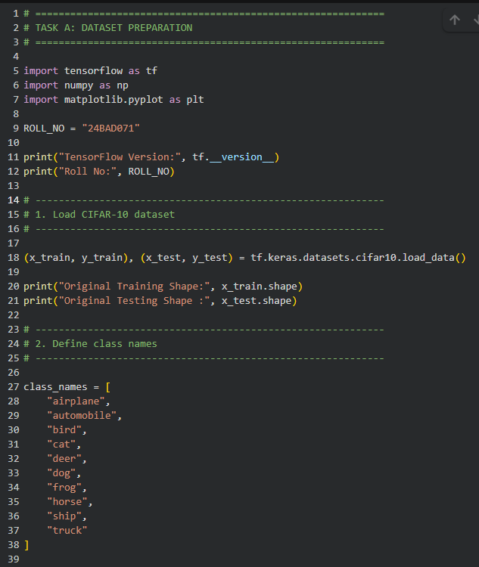
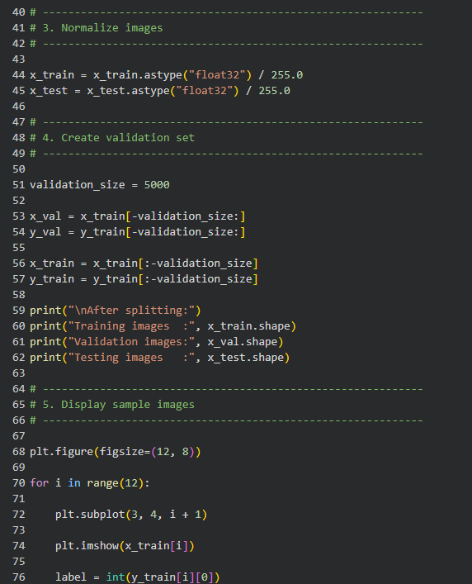
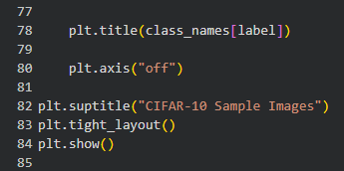

Output:
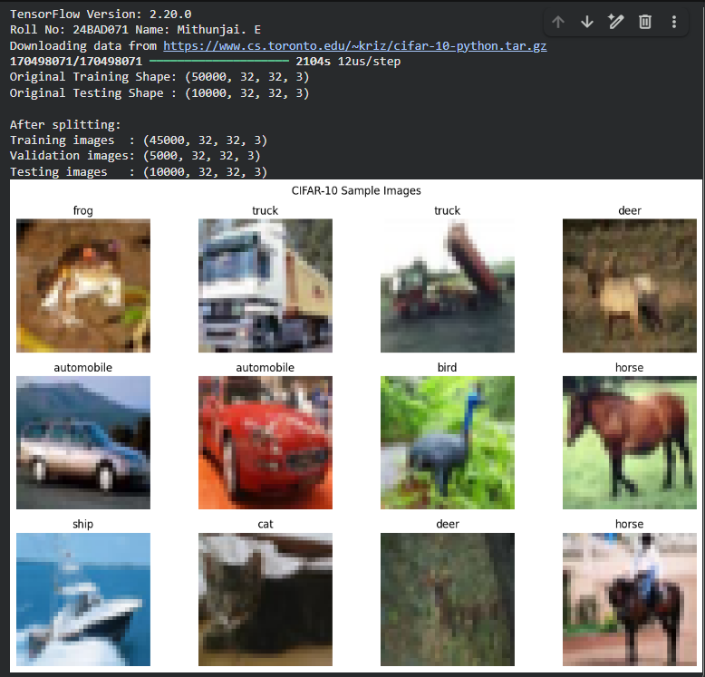

Task B: CNN MODEL IMPLEMENTATION
Build a CNN model consisting of:
- Convolution layers
- ReLU activation
- Max Pooling layers
- Fully Connected layers
- Softmax output layer

Compile the model using:
- Appropriate optimizer
- Cross-entropy loss function

Code:

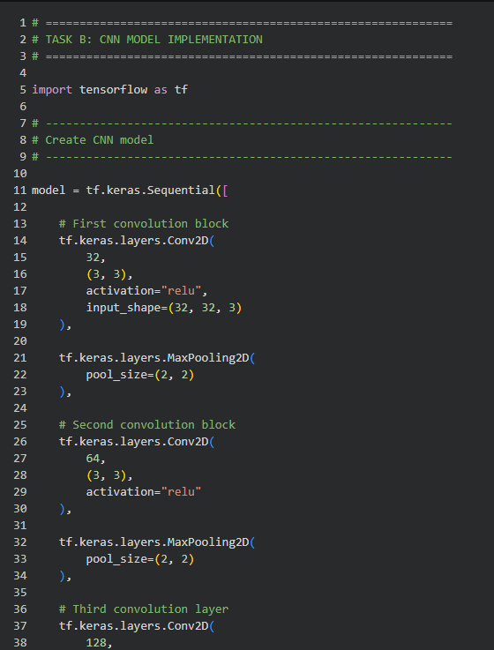
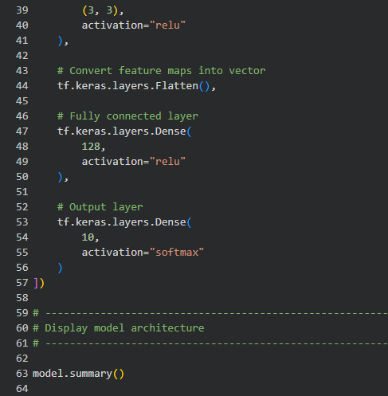

Output:

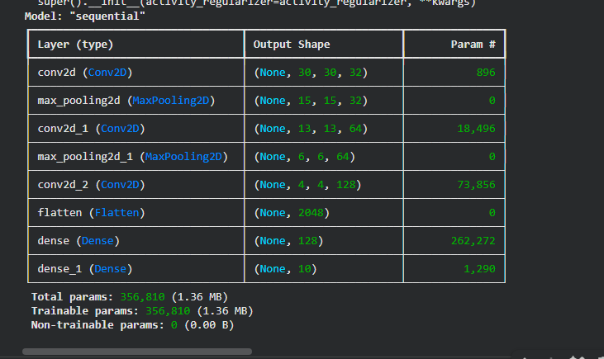

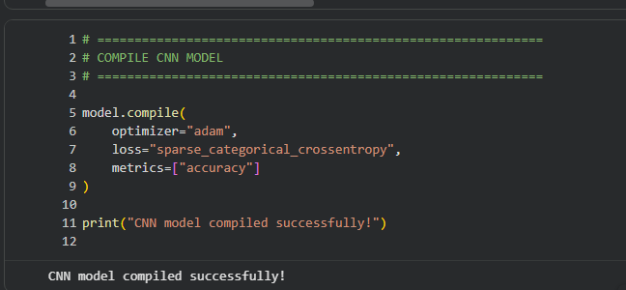

Task C: MODEL TRAINING AND EVALUATION
Train the CNN model.
Record:
- Training accuracy
- Validation accuracy
- Training loss
- Validation loss
- Testing accuracy
Plot:
- Accuracy vs Epoch
- Loss vs Epoch

Code:

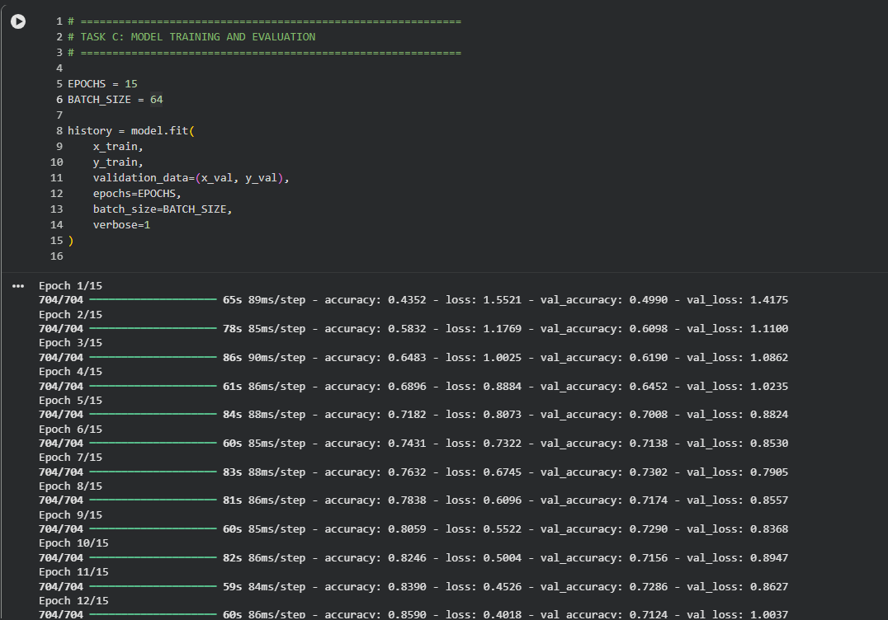
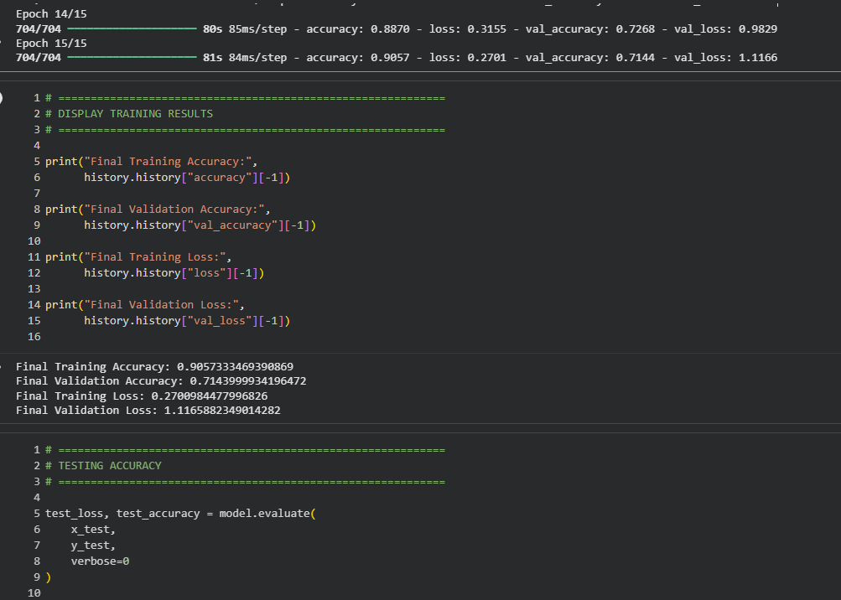
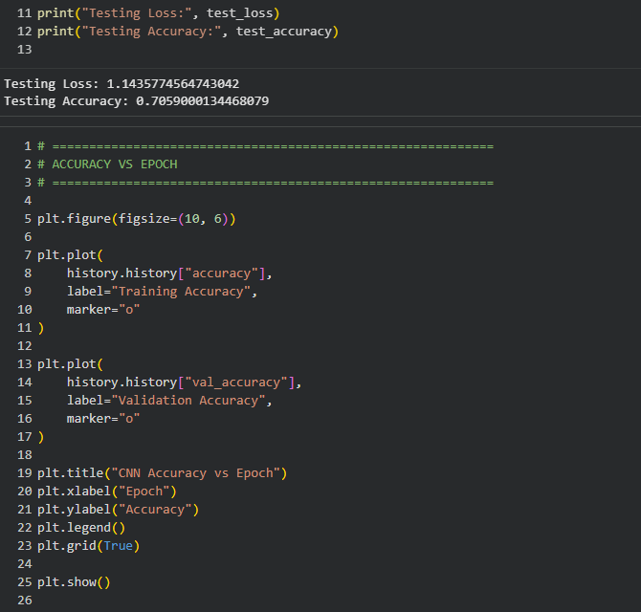
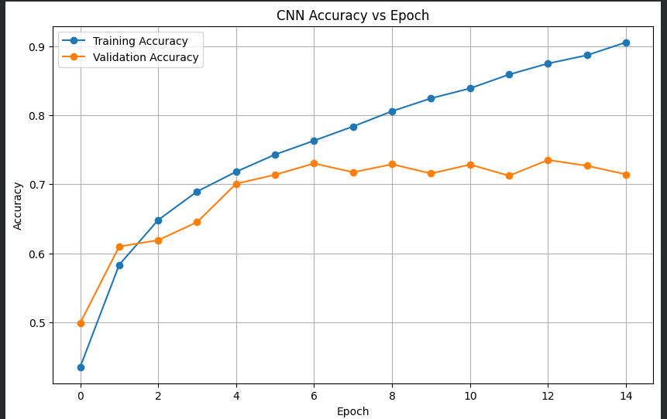
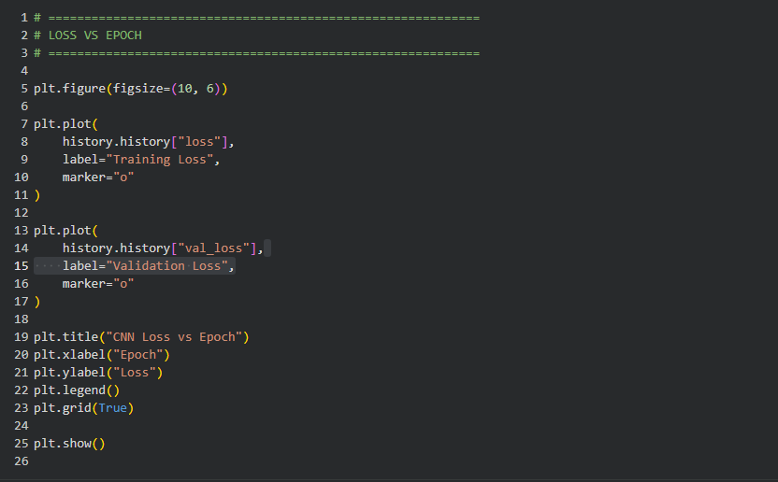
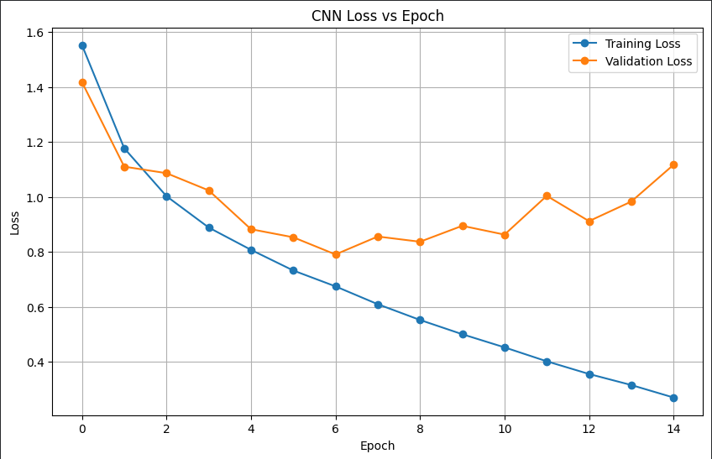

Task D: PERFORMANCE ANALYSIS
Analyze:
- Classification accuracy
- Confusion Matrix
- Sample predictions
- Misclassified images
Discuss the strengths and limitations of CNNs for image classification.

(CODE: CONATAINS STUDENT ROLL NOS
SCREENSHOT OF CODE
SCREENSHOT OF OUTPUT)

Code:
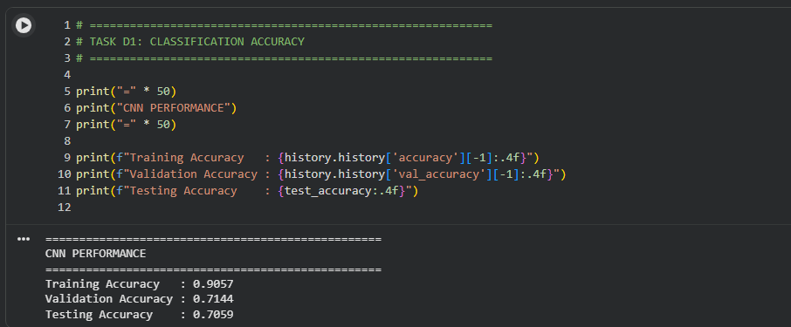
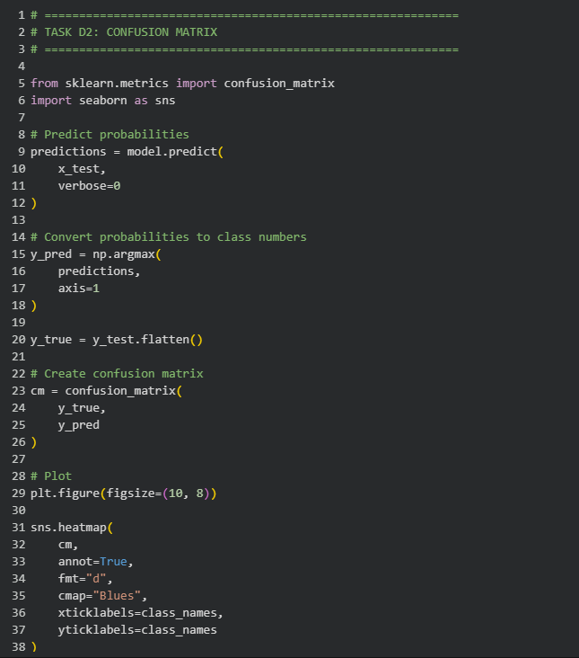
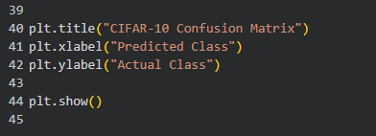

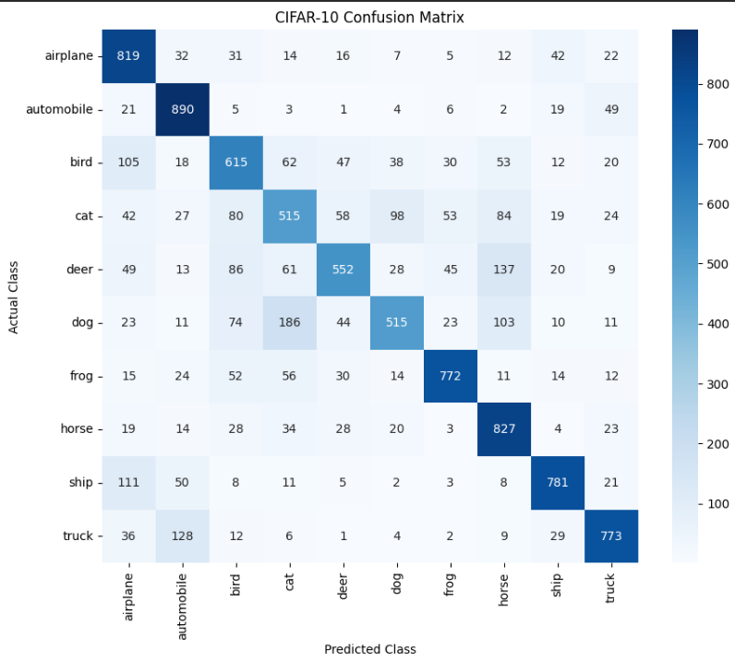

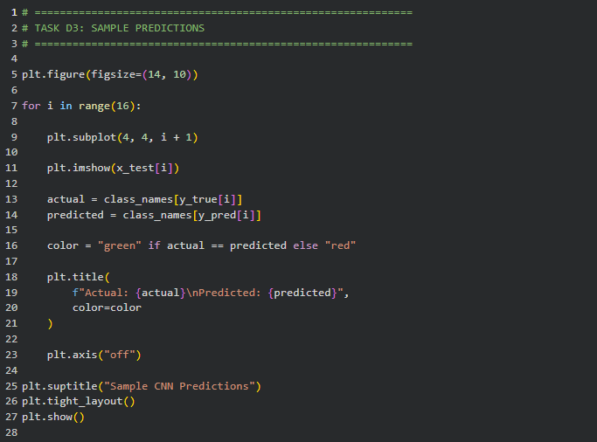
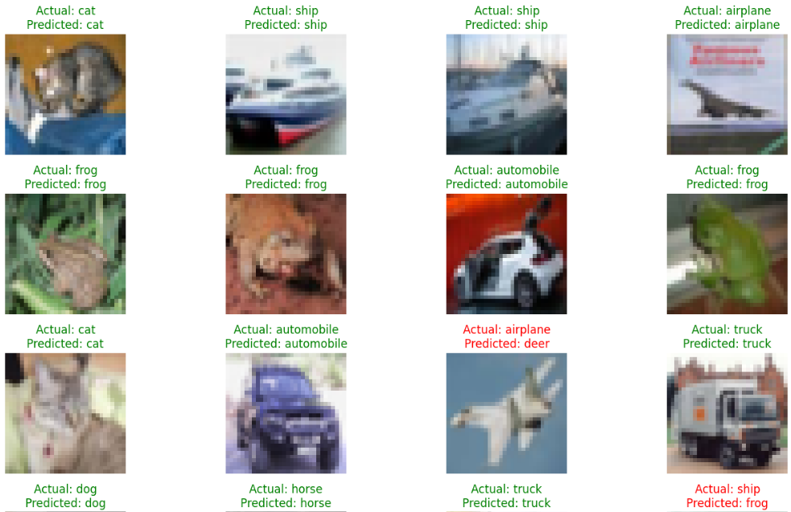
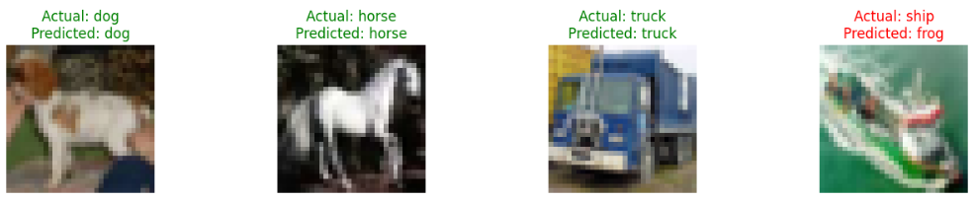
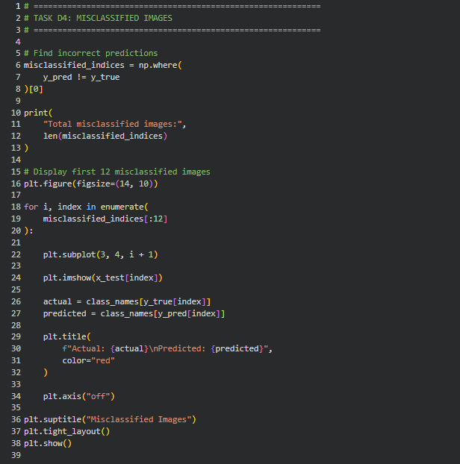
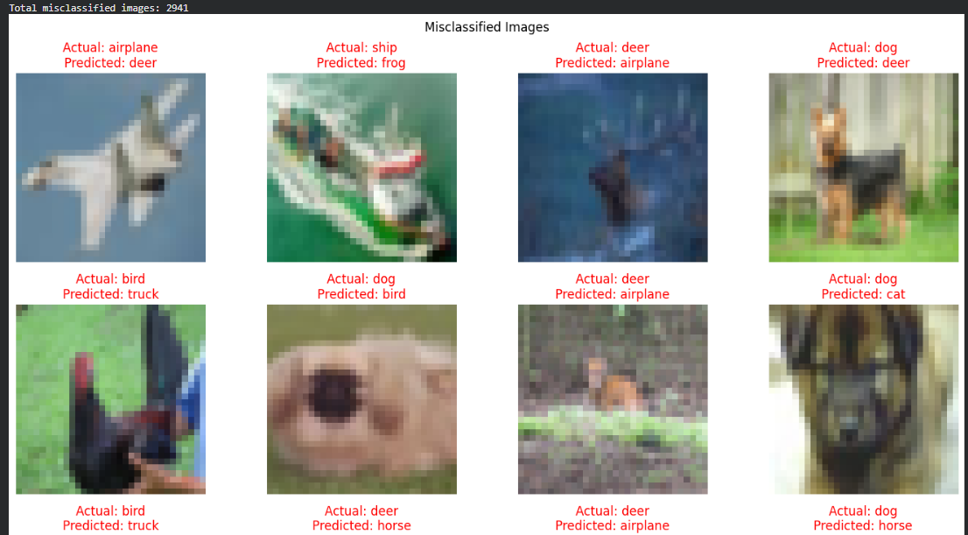
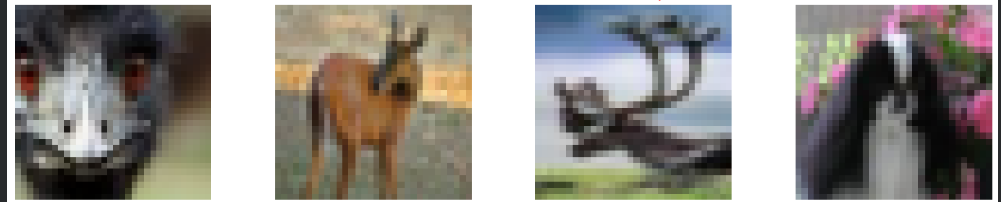
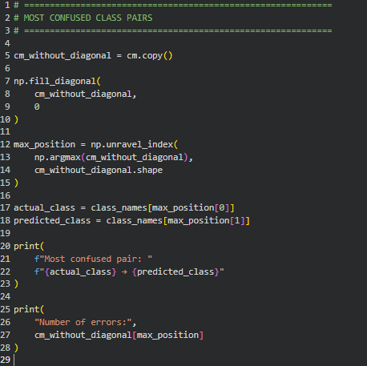

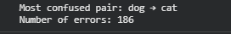
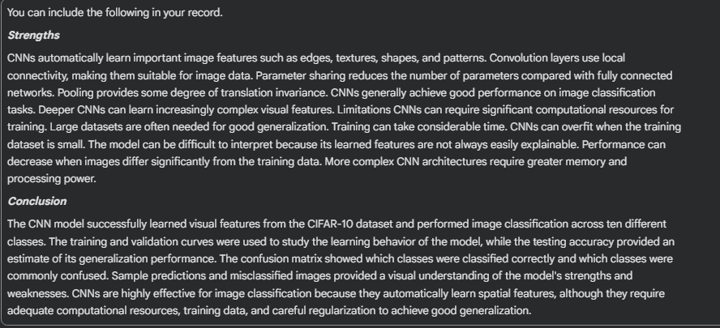

POST-LAB QUESTIONS (PROVIDE BRIEF ANSWERS TO THE FOLLOWING QUESTIONS)

1. Why are convolution layers more effective than fully connected layers for image processing?
  - Convolution layers are designed to process the spatial structure of images.
  - They use small filters to detect local features such as edges, corners, textures, and shapes.
  - The same filter is reused across different locations, which greatly reduces the number of parameters.
  - Fully connected layers connect every input neuron to every output neuron, resulting in many more parameters.
  - Convolution also preserves important spatial relationships between neighboring pixels.
  - Therefore, convolution layers are more efficient, scalable, and effective for extracting visual features.

2. How does Max Pooling improve CNN performance?
  - Max Pooling reduces the spatial dimensions of feature maps by selecting the maximum value from each local region.
  - For example, a 2×2 Max Pooling operation reduces four values to their largest value.
  - This decreases the number of computations and parameters in later layers.
  - It retains the strongest and most important features detected by convolution filters.
  - Max Pooling also makes the model less sensitive to small changes in the position of an object.
  - Therefore, it can improve computational efficiency and help the CNN generalize better.

3. Which hyperparameters significantly affected your CNN model performance?
  - Important hyperparameters include the learning rate, batch size, number of epochs, filter size, and number of filters.
  - The learning rate has a major effect because a very high value can make training unstable, while a very low value can make training slow.
  - The batch size affects training stability, memory usage, and convergence behavior.
  - The number of filters and convolutional layers determines how many and how complex the features the CNN can learn.
  - The number of epochs affects how long the model learns and can lead to underfitting or overfitting.
  - In practice, learning rate and network depth/filter configuration often have particularly strong effects on accuracy.

4. What challenges did you encounter while training the CNN model?
  - One common challenge is overfitting, where training accuracy becomes high but validation accuracy stops improving.
  - Training can also be time-consuming, especially when the dataset is large or the model contains many layers.
  - Choosing suitable learning rates, batch sizes, and epochs can require several experiments.
  - Limited computational resources such as GPU memory can restrict the model size and batch size.
  - Poor-quality or imbalanced image data can also reduce classification performance.
  - These challenges can be addressed using data augmentation, regularization, suitable hyperparameters, and early stopping.

5. Suggest two improvements that can increase the classification accuracy of your CNN.
  - Data augmentation is one improvement; applying transformations such as rotation, flipping, cropping, and zooming can provide more varied training examples.
  - It helps the CNN learn features that are robust to changes in image orientation and position.
  - A second improvement is transfer learning, where a pretrained CNN such as ResNet or EfficientNet is fine-tuned on the target dataset.
  - Pretrained models already contain useful visual features learned from large image datasets.
  - Other techniques such as learning-rate tuning, dropout, batch normalization, and increasing model depth can also improve results.
  - Therefore, data augmentation and transfer learning are two strong practical choices for improving CNN classification accuracy.

ASSESSMENT
Description | Max Marks | Marks Awarded
Pre Lab Exercise | 5
In Lab Exercise | 10
Post Lab Exercise | 5
Viva | 10
Total | 30
Faculty Signature

